**Commands used:**

1. **sudo su (To change the Ec2 user to the root user)**
2. **mkdir (To create a directory)**
3. **cd (change directory)**
4. **touch (to create the file in that folder)**
5. **vim (To write the text in that file)**
6. **cat (to show the text outside that file)**

**Next to Concatenate the content**

1. **cat another_file.txt >> my_file.txt (to concatenate)**
2. **cat my_file.txt (to display the updated content)**
3. **ls -la (to list the all files in the directories)**

**Screenshots:**

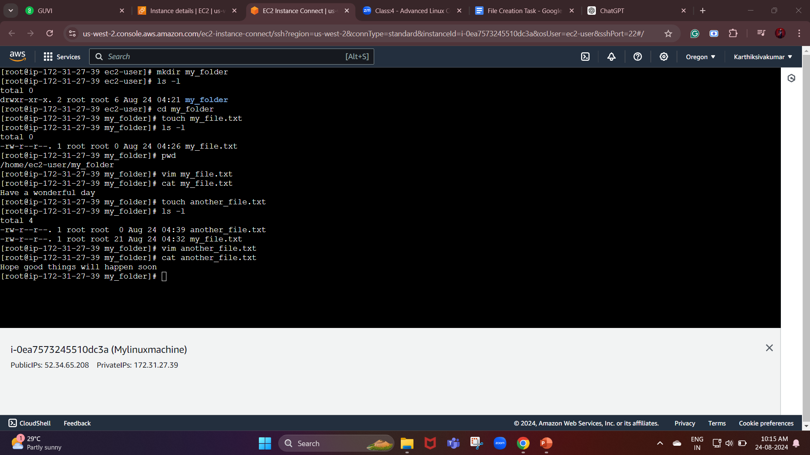

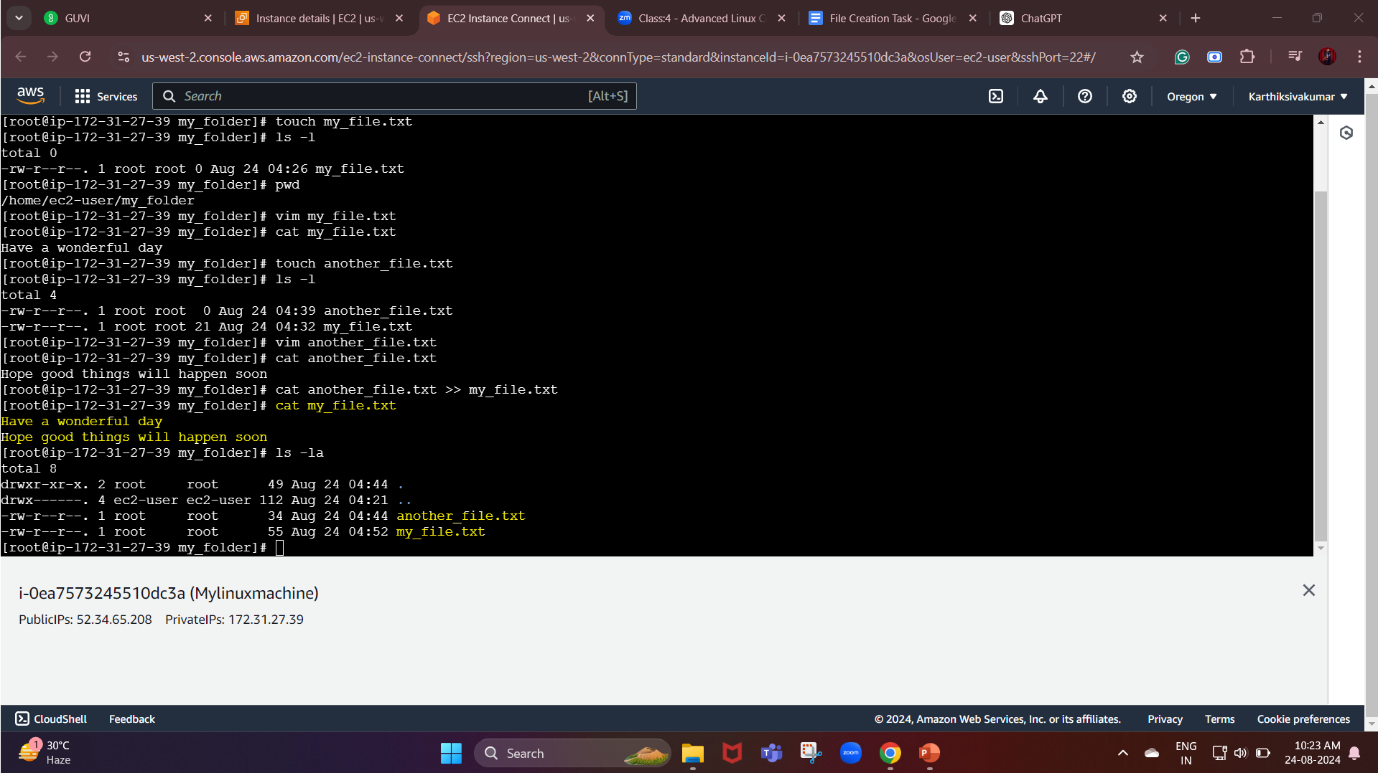

**Create 20 files with .txt extensions and rename the first 5 files to .yml extension and Print the latest created top 5 files among the total no of files.**

**Commands used:**

1. **touch myteamdevops{1..20}.txt (to create 20 files in a moment)**
2. **mv (to change the file name) Ex: (mv file.txt newfile.yml)**
3. **ls -lt | head -n 6 (to list Print the latest created top 5 files among the total no of files)**

**Screenshots:**

